**Floating tenon jig**

This jig is designed to cut mortices in the matching components that will house floating tenons, using a hand-held router. The tenons are quite small as they are for joining box components such as ‘legs’ fitted to the corners.

The jig can be made from plywood or MDF (6 to 12 mm). A vertical hold piece is glued/screwed to the base of the jig so it can be held in a vice, along with the component being morticed.

Two holes are cut in the top of the jig so that two mortices can be routed at fixed repeatable positions. A base plate on the router is used that can house suitable guide bushes. The bushes fit down into the holes that have been cut in the jig to guide the cut. The photos show the top of the jig (Photo 1, left), on which the router plate rests and the underneath, showing a router bit being used to cut the hole (Photo 2, right).

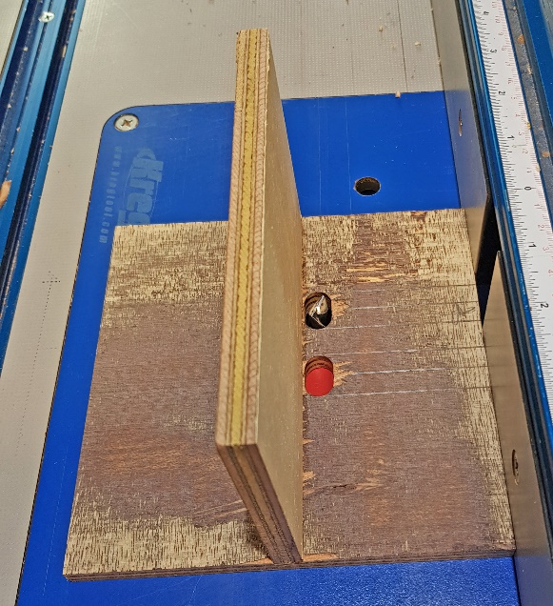

The diagram of the jig I have made shows that the mid-points of the holes are 34 mm apart. The holes are 20 mm long and 12 mm wide (Photo 3, below). The stock I used is about 12 mm thick so with the holes lined up adjacent to the vertical holder, the mortices are cut close to mid-way in the sides.

I have used a bushing with an external diameter of 11 mm with a 4 mm spiral cutter. This results in a mortice that is about 5 mm wide (since the hole cut in the jig is about 1 mm wider than the bush).

Note that the router bush holds the bit 3.5mm from the sides of jig. This means that the length of the tenon is 7mm less than the length of the hole (2 times 3.5mm) and the tenon is 3.5mm from the side of the workpiece. These dimensions will change depending on the size of the bit and bush you use with your router.

Unfortunately, the bushing that is normally supplied when you purchase a router is quite large. The bushings with the routers that I have purchased are 17 and 18 mm in external diameter. This means that if you wish to use a 4 mm bit and say a 1 mm gap, then the hole required to be cut in the jig is in the order of 19 mm wide and 27 mm long. This hole will thus go beyond the edge of the vertical hold piece and almost join the two holes lengthwise. If you only have a supplied bushing, it may thus be best to rout only one mortice at a time (one hole in the jig). I purchased a Milescraft bushing set that comes with a separate base which attaches to your router and accepts a range of supplied bushings.

Make your own tenons by thicknessing a scrap piece of wood so it just fits into the mortices. Cut them to width first and then cut to length. The tenons can be made any suitable length that provides a strong joint. I have used 14 mm each side (28 mm total length). Note that the holes shown in the diagram are rectangular, whereas they are normally cut with a router, giving rounded ends. When using a guide bushing, this is irrelevant as the bush does not follow the corners of a rectangle. I have used a 4 mm gap between each offset mortice so the 34 mm between each centre point is made up of: 6.5 + 4 +13 + 4 + 6.5.

Great care is needed in setting out the positions of the two joints on the side components and the legs, so that when the adjacent side of the leg is done, the offset is accurate. It is worth doing an accurate drawing of your chosen offset mortices and tenons, plus the gaps in-between so you can be sure of the measurements before you start. Mark the mid-points of both mortices on the component and line them up with the mid-points marked on the jig. Lock the jig and the component into the vice for cutting the mortices. Make sure that the router is fitted with a vacuum line to clear chips as you cut and take two or three separate passes to reach full depth, cleaning the joint after each cut. Position the router bushing over the hole, plunge the router so it cuts about 5 mm and work the router back and forth in the hole. Repeat for the next 5 mm in depth. Photo 4 (below right) shows the offset tenons in the side components (front) and front/back components (back).

Robin Cromer - September 2021

Offset tenons